Ansible

* Its a config mgmt tool (push mechanism)
* Its an open source IT tool which automates application deployment
* It uses YAML scripting works on key-pair
* Ansible was taken over by red-hat (developed by michale dehhan)

**Ansible workflow**

* Primary stages are ansible server >> playbooks>>Nodes
* Where we can install apps remotely to the end users using the ansible server or by playbooks  
    
   **Ansible server**

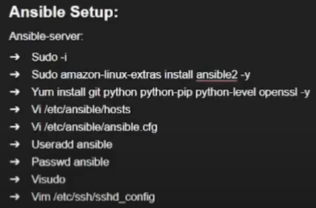

* In hosts we need to add the vm’s private ip’s
* In the ansible.cfg what we use we need to uncomment them (inventory, sudo user)
* Create ansible user and password and then make it as a superuser using (visudo)
* To do passwordauthentication **YES** then we need to go to the vi etc/ssh/sshd_confg

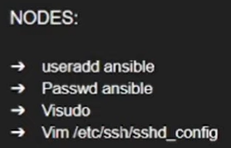

* Need to restart the sshd service (systemctl restart sshd)
* Login as ansible user in all the servers
* Now we need to generated a key (ssh-keygen) that key will be stored in the path of home/ansible/.ssh
* We need to connect to the ansible server so we need to use the command in the ansible server

(ssh-copy-id ansible@localhost ) (ssh-copy-id ansible@publicip)

* Ansible inventory pattern (can be able to find the which nodes are present in the which groups of the ansible server) cmd : ansible all –list-hosts (in place of all replace with group name)
* If we want to push code from the ansible server to the nodes can be achieved by 3 ways  
   Ad-Hoc commands (basic linux commands which are written btw “” of ansible grp -a “commands”)  
   Modules  
   Playbooks

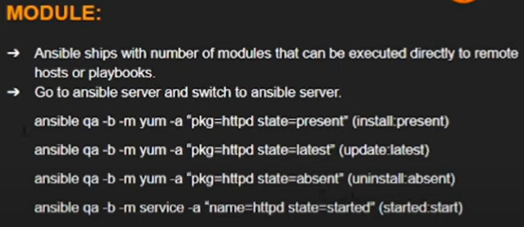

* How to create a user in ansible   
  **ansible qa -b -m user -a “name=ravi”** (to check userlist cat /etc/passwd) **ansible qa -b -m copy -a “scr=filename dest=/tmp”** (to copy a file to the nodes from ansible server)

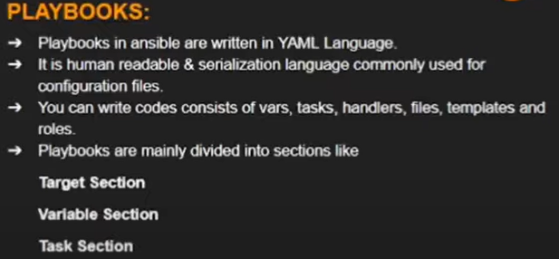

**PLAYBOOKS**

* *Create a file with extension* ***file.yml*** *— # This is the demo yaml file*

*Hosts : grp  
User: ansible  
Become: yes  
Connection: ssh*

*Vars:  
 Pkgname: git  
Tasks:  
 - name: installing maven in this group  
 Action: yum name=’{{pkgname}}’ state=present*

* Inorder to execute yaml files use this command (ansible-playbook file.yml)

